**ANALYSIS OF CHAIR’S REPORT TO THE SMALL WORKING GROUP ON THE FUTURE OF THE IWC**

**IWC/M10/SWG 4**

**March 2010**

**Prepared and/or endorsed by:**

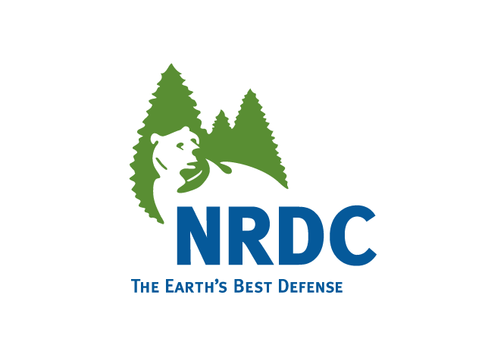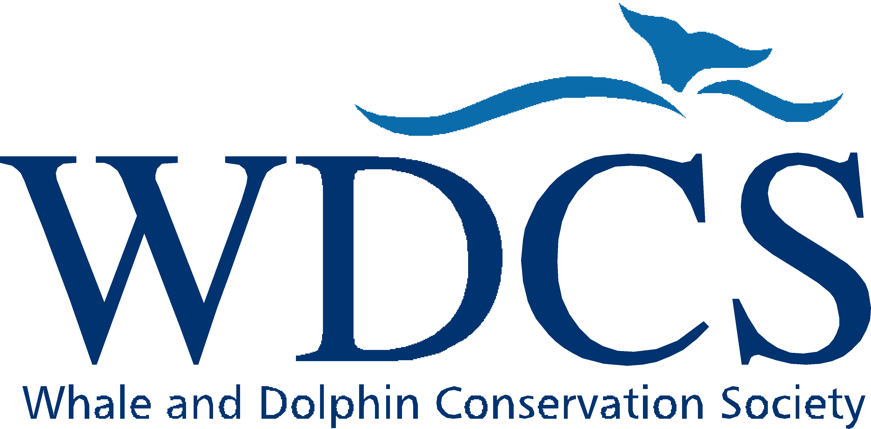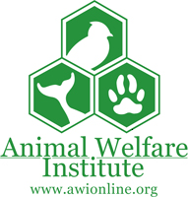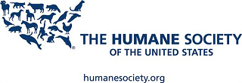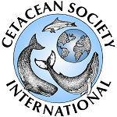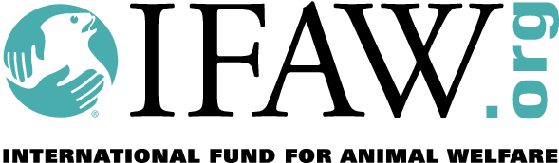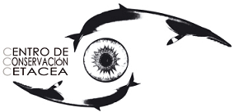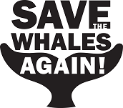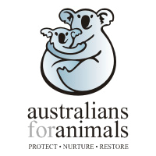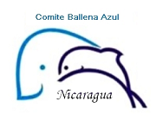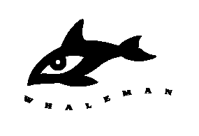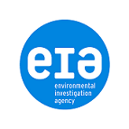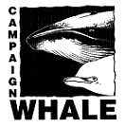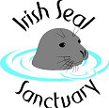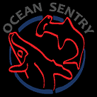

**H**

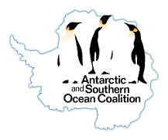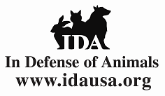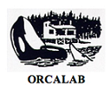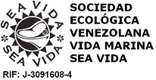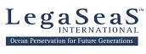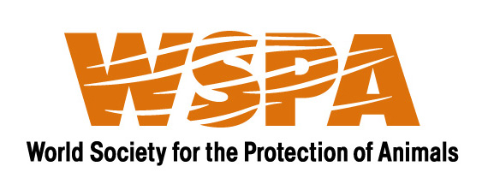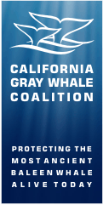

**Synopsis of Concerns Relevant to the Chair’s Report to the Small Working Group on the Future of the IWC**

* The Package legitimizes commercial whaling by suspending the commercial whaling moratorium for a decade. This is inconsistent with Schedule Paragraphs 10(d) and 10(e).
* The Package cannot legally limit whaling to only Japan, Norway, and Iceland as the International Convention for the Regulation of Whaling (ICRW) does not permit quotas to be granted to specific nationalities.
* The Package does not prevent contracting governments from exercising their right in the ICRW to object to any or all of the Schedule amendment, or from leaving the Commission and returning with a reservation. A commitment not to do so in the Schedule is not binding.
* The Package does not prevent one or more countries from exercising their right in the ICRW to issue special permits (under Article VIII) anytime during the duration of the Package A commitment to do so in the Schedule is not binding.
* The Package does not phase whaling down or out.
* The Package legitimizes whaling in the Southern Ocean Sanctuary -- an IWC-established sanctuary.
* The Package fails to provide adequate compliance mechanisms or sufficient deterrents for violations since contracting governments, not the IWC, will have primary authority to punish violations.
* The Package is not based on sound science. Catch limits will not be calculated using the IWC agreed precautionary scientific approach, the Revised Management Procedures, or even subject first to consideration by the Scientific Committee. They would be based on recent or historic catches (that have increased in recent years in apparent anticipation of this Package) with some potential manipulation to make the limits more politically palatable.
* The Commission would require a three-quarters majority to amend the quotas in Table 4 in the event that the Scientific Committee recommended lower catch limits, or to punish nations who violate those quotas by reducing catch limits. A three-quarters majority may not be possible to achieve.
* The Package fails to require the whaling nations to give up their reservations to the CITES Appendix I listing of whales. It provides an incentive for the whaling nations to continue trading with each other under reservation and to develop new commercial products from whale tissues and oils and develop new markets for the trade in whale products in the future.
* The Package may increase the likelihood that CITES downlists whales (allowing international commercial trade to resume). A commitment by the whaling nations, or even all 88 IWC members, not to propose or support a downlisting at CITES is irrelevant because CITES has 175 Parties and it is unlikely that all 88 countries would uphold their commitment in a secret ballot.
* The Package fails to consider that the whaling industry is uneconomical without substantial government subsidies. It thereby provides a lifeline to a dying industry.
* The Package could be extended *ad infinitum* by repeatedly changing the Package expiration date in the Schedule.
* The Package proposes a biennial meeting schedule for the Commission that is unworkable and inefficient, leading to a workload that cannot be completed. It is also inconsistent with the annual reporting requirements for many existing and proposed issues that the Commission is charged to consider.
* The Package imposes the costs of regulating whaling on all Contracting Governments, not just the whaling nations that will benefit from it. This may drive some nations to leave the IWC. Allocating these costs to non-whaling nations is unbalanced as there are no comparable fee structures proposed to help nations build or maintain their whale watching industries.
* The Package inappropriately combines Aboriginal Subsistence Whaling (to now be called Indigenous Subsistence Whaling) with commercial whaling for political, not scientific or management reasons. By eliminating the IWC’s historical practices of reviewing ASW quotas every five years, it undermines the integrity of the ASW category and threatens the status of vulnerable whale populations taken in ASW hunts. It is inconsistent with the Commission’s decision in 2008 to exclude ASW from the list of 33 priority issues.
* The Package fails to mandate that bycaught whales be accounted for in Table 4. If not remedied, this deficiency could encourage in increase in bycaught whales.
* The Package does not meaningfully address animal welfare issues. It fails to ensure that high quality and objective information on whale killing methods and time to death are reported and fails to mandate improvements in techniques and/or weaponry to reduce the suffering of hunted whales.
* The Package does not appropriately address civil society participation in IWC meetings. It continues to restrict full participation by all observers in IWC proceedings and committees and fails to adopt civil society participation standards consistent with modern multi-lateral environmental treaties.
* The Package will make it more difficult for the European Community to use Iceland’s application to join the EC as leverage to stop its whaling and trade.
* The Package was developed using a process that lacked any transparency. It prevented IGOs and NGOs from having any input or role in the negotiations.

**Introduction:**

The Support Group issued a draft document titled “Consensus Decision to Improve the Conservation of Whales” (hereinafter referred to as the “Package”) on February 22, 2010. The Chair’s Report emphasized that it is a draft, and that no consensus has yet been reached. There is no doubt that the International Whaling Commission (“IWC” or “Commission”) must find a way forward. This Package, however, is not the way.

Although the Package’s “Vision Statement” promises conservation, the Schedule amendments do not contain any meaningful conservation gains that would compensate for the alarming flaws in the Package itself. The Package, if adopted, would amend Chapter VII of the Schedule to legitimize Japan, Norway and Iceland’s whaling. The Package would allow Norway and Iceland to engage in commercial whaling and permit Japan to remove the disguise from its “scientific” whaling so that it can, as it has been doing for decades, whale commercially – while still allowing all three countries to use Article VIII of the International Convention for the Regulation of Whaling (“ICRW”) to supplement any quotas allocated by the Commission. Yet it makes no provision for phasing whaling down, or out, during the ten-year interim arrangement. Further, there is no requirement that the number of whales killed after 2010 will remain as low as the interim levels. Nor does the Package address what type of whaling will be authorized by the IWC when the interim arrangement ends in 2020 (or later if extended). Even if the whaling countries comply with the terms of the Package, once it expires they will be able to return to commercial whaling under objection, reservation or Article VIII. This could result in much higher levels of whaling than before or during the interim arrangement. However, having legitimized Norway, Iceland and Japan’s whaling for ten years, the Commission will not have either the political or legal momentum prevailing today to address it. The world will have moved on and the conservation of great whales, consequently, would not have been advanced.

In short, the Package essentially depoliticizes commercial and special permit whaling - without ending either. It legitimizes whaling for at least a decade effectively rewarding, not penalizing the whaling nations for their decades of intransigence and disregard to the repeated requests of the international community to cease whaling. It also ignores the substantive scientific evidence demonstrating that special permit whaling is not necessary for knowledge or management of cetaceans. The Package represents a step backwards, not forwards, for the IWC, and it will eliminate or degrade decades of positive change, albeit achieved in small increments, for whales.

This draft analysis will be followed by a more detailed review of the Package and its annexes in due course.

1. **Relationship Between the Proposed Package and the ICRW: Commercial Whaling, Scientific Whaling, Objections and Reservations**

|  |  |
| --- | --- |
| Issue | Analysis |
| The Package would legitimize Japan, Norway and Iceland’s whaling | The proposed new Chapter VII of the Schedule allows Japan, Norway and Iceland to continue to hunt the same species in the same areas for ten years under an interim arrangement of IWC-approved monitoring, control and surveillance (MCS) provisions. Although Chapter VII would prevail over certain other provisions in the Schedule in the event of an inconsistency, the Package acknowledges that Contracting Governments retain the right under the treaty to unilaterally authorize whaling under Article V (objection) and VIII (special permit whaling). To address this, Contracting Governments agree temporarily in Chapter VII not to exercise those rights (“No Contracting Government will unilaterally authorize any whaling in excess of the limits shown in Table 4 or outside the provisions of chapter VII”). Notably, however, they do not give up those rights. Nor does Chapter VII supersede any of their rights under the ICRW. |
| The Package will suspend the international moratorium on commercial whaling (Sections 10(e) of the Schedule) | The proposed new Chapter VII of the Schedule would effectively suspend 10 (e). Although Paragraph 32 does not explicitly supersede Schedule Paragraph 10(e), it states that, in the event of an inconsistency between Chapter VII and other provisions in the Schedule, Chapter VII would prevail over other provisions. Allowing commercial whaling is clearly inconsistent with both Schedule Paragraphs 10(d) (which provides a moratorium on factory ship whaling of all species except minke whales, and to which no countries have objections) and 10 (e). |
| If Norway or Iceland object to any of the quotas provided in Table 4, or any other component of the Package, Section 10(e) is NOT the default and their quotas will NOT revert to zero | Currently Iceland has a reservation and Norway an objection to the moratorium. Therefore, neither country is bound by 10(e). If they object to the quotas in Table 4, they will be able to set their own catch limits unilaterally. Japan would be the only country bound by 10(e) as the default. |
| An agreement in the Schedule cannot prohibit special permit whaling under Article VIII of the ICRW | The ICRW cannot be amended through the Schedule. Article VIII of the ICRW states:  “Notwithstanding anything contained in this Convention any Contracting Government may grant to any of its nationals a special permit authorizing that national to kill, take and treat whales for purposes of scientific research subject to such restrictions as to number and subject to such other conditions as the Contracting Government thinks fit, and the killing, taking, and treating of whales in accordance with the provisions of this Article shall be exempt from the operation of this Convention…”  Technically then, Japan could still issue special permits **and** avail itself of the new quota given in Table 4 of the package with impunity.[1] In addition, this Package does not prevent any new government from joining the IWC andissuing special permits to engage in special permit whaling. |
| The Package cannot legally limit whaling to just Japan, Iceland and Norway | Article V of the ICRW states in relevant part:  “These amendments of the Schedule … (c) shall not involve restrictions on the number or nationality of factory ships or land stations, nor allocate specific quotas to any factory ship or land station or to any group of factory ships or land stations; ….”  Granting quotas to certain nationalities while prohibiting others from being granted similar quotas violates the Convention, establishes dangerous legal precedent, and represents a discriminatory act by the IWC. Such restrictions also go against IWC precedent and practice when allocating quotas. The Package does not propose any conflict resolution procedures in the event that a Contracting Government challenges this, or any other, provision. |
| Contracting governments may take an objection to all or part of the Package within the 90 day period allowed by the ICRW | It is the right of any Contracting Government under Article V of the ICRW to take an objection to any part or all of a Schedule amendment. A Government can agree to be bound by part of the Package but not all. For instance, South Korea could object to the provision limiting IWC approved quotas to Japan, Norway and Iceland – but agree to the quotas in Table 4. Likewise Japan could agree to be bound by the quotas – but object to the compliance provisions. These objections can be lodged AFTER the adoption of the Package (by ¾ majority), meaning whaling nations could agree to commitments in order to get the Package adopted and later object to those same commitments. This allows for bad faith negotiations by any and all contracting governments. The Package does not account for this eventuality; for example, by providing that any objections or reservations to the Schedule amendment would trigger an immediate sunset, or dissolution, of the entire Package. |
| New members joining the IWC will not necessarily be bound by the Package | Iceland believes it set a precedent whereby a new member (even a rejoining member) can take a reservation to any part of the Schedule and not be bound by it. A new or rejoining member could therefore engage in commercial whaling by simply seeking to take a reservation to the Package. |
| No ramifications if a country or countries object, take a reservation, or issue special permits at the outset or during the ten year period of the Package | The Package stays in place for ten years regardless of whether countries circumvent the deal. The quotas in Table 4 could be lowered as a possible penalty; however, no meaningful consequences will result from whaling outside of the Package. To ensure the integrity of the deal as a whole, the entire package would need to sunset if objections or reservations were taken. There is no provision (as was discussed for the Revised Management Scheme (RMS)) of reducing quotas ‘whale for whale’ if countries continued to conduct scientific whaling on stocks or species subject to a commercial quota. |
| It is almost impossible to prevent countries from taking reservations, objections or issuing special permit whaling during the ten year period of the Package | The only way to ensure that whaling does not occur outside of this Package is to create multi-lateral binding agreements that would go into effect before or simultaneously with the adoption of the package. A multi-lateral binding agreement(s) could require countries to not exercise their rights under the ICRW for a ten year period. These binding agreement(s) would need to be ratified by all participating governments and would not be binding on any new members that may join the IWC in the next ten years if they exercise selective reservations. |
| The Package will not phase whaling down or out | The Package makes no provision for phasing whaling down, or out, during the interim arrangement and there is no requirement that the number of whales taken after 2020 will remain as low as the interim levels. Nothing prevents Norway, Iceland and Japan from resuming their whaling under objection, reservation or Article VIII after 2020, or even during the interim period, and other Contracting Governments could start whaling under Article VIII, or leave and rejoin the Commission with a reservation, at any time. Indeed, the package actually locks into place an increased number of target species and sets the stage for potential increased quotas in ten years time. |

1. **Methods for Enforcement and Compliance are Sorely Lacking**

|  |  |
| --- | --- |
| Issue | Analysis |
| The Package will not ensure adequate compliance or provide sufficient deterrents for violations | The Package will not ensure adequate compliance with new whaling catch limits and protocols. The Governments whose vessels commit the infractions – not the IWC – will have the authority to punish violations of the agreement. Specific sanctions for violations are not mandated. Rather, Governments “shall take appropriate enforcement measures in accordance with its domestic law.” Although possible sanctions – including suspension of the whaling vessel’s license, deprivation of economic benefit from illegal whaling, fines, and seizure of any whale or whale part taken unlawfully – are listed in Annex {LIS}, the Package does not require Governments to impose any of those sanctions nor does the Package prescribe a time-frame for imposing the possible sanctions or a requirement that sanctions are actually complied with. Furthermore, it remains unclear what domestic laws are available in any of the whaling nations to provide such an enforcement mechanism.  Paragraph 35 of the Package does give the IWC some meager authority to punish violations by allowing the Commission to reduce catch limits for violations the following whaling season. But a reduction in catch limits would require a three-fourths majority under Articles III and V of the ICRW, thus potentially leaving the IWC without any authority whatsoever to punish infractions. Furthermore, noting that the Commission is proposed to meet only every two years, additional whaling seasons could have passed before the Commission responds to a report from the Management and Compliance Committee. Such a vague and weak enforcement standard is entirely unacceptable. |

1. **Quotas and Catch Limits Do Not Represent Sound Science or a Robust Scientific Review Process**

|  |  |
| --- | --- |
| Issue | Analysis |
| The Package is not based on sound science | At the start of the ten-year period, the Package would establish catch limits that have not been calculated via the IWC’s agreed precautionary scientific approach, the Revised Management Procedure (RMP). Instead, until the Scientific Committee has completed the RMP implementation process for a specific stock, the quota for that stock would seemingly be set based on the whaling countries’ recent or historic catches, with possibly some reduction to make them appear more politically palatable.  The Package states that it expects to have numbers ready to discuss at the March meeting of the Small Working Group, which indicates that these numbers will not first be considered by the full Scientific Committee. The established catch limits are thus erroneously referred to as “agreed sustainable limits” in the Package. The Package states that these limits will be “provisional measures” that will have been agreed upon using “best available information.” However, it is not clear how they will be calculated and whether the Scientific Committee may be put in the invidious position of being asked to agree to some figures set because they are politically expedient or, if it doesn’t do so, to be accused of blocking the package. Allowing whaling using quotas based on recent or historical catches, without first determining if they are, at a minimum, sustainable is inconsistent with the precautionary principle that is intended to influence all IWC decisions. Moreover, as specified by the United Nations Convention of the Law of the Sea and as has been the declared policy of the IWC since 1974, recovery to optimal stock levels, not mere sustainability, is the overriding standard which is not met by the Package.  Similarly, the Package states that if there is a significant event that negatively affects the status of a stock, the Commission will lower the catch limit for that stock prior to the next whaling season based on the advice of the Scientific Committee. This is impossible and potentially dangerous to affected whale populations since evidence indicating a significant event – if detectable[2] – would not be uncovered and presented until well after those whales have already been targeted. Further, given the time taken for the Scientific Committee to meet, analyze the data, and decide on its advice and then for the Commission to meet, up to two years later, and agree to that advice, presumably on a three-fourths majority vote, the opportunity to meaningfully reduce the catch limit will have long since passed, making the process completely unpractical and ineffective. |
| The Package is based on political quotas | The Package acknowledges that the quotas agreed will reflect policy as well as scientific evaluations, *i.e.* the whaling nations will not agree to a quota that tips their industry beyond a financial “breaking point.” Furthermore, by doing nothing to prevent whaling nations from trading whale products internationally, the Package helps the whaling nations keep alive the prospects of more profitable whaling in the future. The whaling industry in Norway has already indicated its expectations that the Package will allow them to strengthen their industry by allowing for exports and to recruit new whalers. |
| Implementation reviews will take too long to guarantee sustainable whaling | The Package states that implementation procedures, including implementation reviews, would be undertaken for those targeted whale populations for which an RMP implementation process has yet to be undertaken or is outdated[3] and proposes a schedule for completion of the processes.  Under this Schedule, the earliest implementation review would be 2013 for western North Pacific Bryde’s whales – two years after the catch limits had been assigned. If Japan’s self-appointed historic catch quotas for this population are used as an example, then 50 animals a year would have been taken before the implementation review on the sustainability of such a take would be completed (assuming that it continues on schedule). For other populations, according to the timetable contained in the Package, implementation reviews would not take place until three, seven, eight and nine years after the catch limits had been set. This assumes that the schedule in the timetable is realistic which, as conceded in the Package, it may not be. Such an approach is certainly not the precautionary approach promised on page 2 of Part 2 of the Package.[4]  Furthermore, with the Commission meeting only every other year and decisions on catch limit revisions requiring a three-fourths majority, it is entirely possible that adjustments to the catch limits to correct initial grossly overestimated “sustainable limits” would either be too late or be blocked by pro-whaling nations. The Package does not account for what would happen if, late in the ten year interim period, the RMP gave significantly lower quotas than had been taken for years under the interim catch limits in Table 4. By the time any mistakes are corrected, the whales would already be dead. |
| Both Norway and Iceland have recently inflated their quotas, presumably in anticipation of the “reductions” in the Package | Norway sets its quotas in 5 year blocks. From 1996-2000, Norwegian fishery authorities set national catch limits for minke whaling using a version of RMP with a tuning level of 0.72. After 2001, when it was discovered that catch limits would be significantly reduced (due to a high proportion of females having been killed during the 1996-2000 block), Norwegian authorities changed the tuning level used to the less conservative 0.66. In 2003, after new abundance estimates showed far fewer minke whales, the tuning level was changed yet again to 0.62. The tuning level was then further dropped to 0.60 in 2005.  Despite the fact that Norway has continuously worked to inflate its quotas by using increasingly less conservative tuning levels, Norwegian whalers have fallen short of the proposed national quota in all but one of the last 16 years, resulting in quota carryovers of unused quotas from one year to the next.  Norway has set an astounding quota of 1,286 minke whales for 2010. This represents the annual quota for 2009 of 885 plus 401 whales that were not taken last year.  Of this quota, 1,016 minkes can be killed in the Norwegian economic zone and the Svalbard fisheries area, and in international waters within IWC areas ES, EN, EB and EW. The remainder can be hunted within the Jan Mayen fishing zone and in international waters in IWC area CM; whereas in the past Norway controlled its whaling both by using per vessel quotas and small area quotas, these have been abandoned in recent years in an apparently unsuccessful effort to encourage larger takes.  Iceland increased its self allocated whaling quotas from 40 minke whales in 2008, to 150 fin whales and at least 100 minkes in 2009. The Marine Research Institute of Iceland has indicated that it recommends quotas of at least 200 fin whales and 200 minke whales for 2010. |

1. **The Package Ignores Economics and Costs**

|  |  |
| --- | --- |
| Issue | Analysis |
| The Package does not take into account the fact that whaling is an unviable industry without large government subsidies | The Package ignores the economic context of whaling in Norway and Japan, where operations would fail without continued large government intervention (including large subsidies) and the prospect of reviving large scale exports. A recent independent economic analysis of whaling in Japan and Norway, which considers a range of direct and indirect costs associated with whaling and the processing and marketing of whale products, concludes that these costs, combined with declining markets for whale meat and the risk of negative impacts such as trade or tourism boycotts, make commercial whaling economically unviable in both countries without huge government subsidies.  For example, during the 2008-09 season, the Japanese whaling industry needed US$12 million in taxpayer money just to break even. Sales of whale meat, blubber, and other whale products in Japan have not produced sufficient revenue to pay for its whaling operations most of the last 20 years, requiring the Japanese government to subsidize the industry by US$164 million since 1988. In Norway, government subsidies for the whaling industry have typically equaled almost half of the gross value of all whale meat landings made through the Rafisklaget, the Norwegian Fisherman’s Sales Organisation. The number of whaling vessels participating in each year’s hunt is declining in Norway - from 32 in 2005 to just 21 in 2009. To encourage a greater involvement in whaling, the government is now considering licensing sealing vessels to hunt whales.  In addition, Icelandic whaling has also benefited from government support; between 1996 and 2006, the Icelandic government spent some 748.8 million ISK (10.1 million USD) on projects and lobbying in support of the whaling industry.  Now is not the time to give the whaling nations hope of future economic sustainability. |
| The Package does not address costs | The Package does not provide details on how, and by whom, the additional costs of the interim arrangement will be met, but indicates that the Commission will make a detailed assessment of how to apportion these costs amongst Contracting Governments through the Contributions Scheme. This suggests that all Contracting Governments will share the burden while the whaling nations reap the benefit instead of a ‘user pays’ scenario where those killing whales will be responsible for all costs. As presently proposed, increased costs could result in the departure of some governments from the commission due solely to the increased economic burdens of membership. |

1. **The Timeframes Established by the Package are Problematic**

|  |  |
| --- | --- |
| Issue | Analysis |
| The Package could be extended ad infinitum | The quotas, MCS provisions and suspension of rights contained in Chapter VII expire on a specified date in 2020 without the need for a further Schedule amendment. However, the “expiration date” could simply (and repeatedly) be extended by changing the dates in the Schedule. This has been the practice with ASW quotas in Paragraph 13. This is a likely scenario considering how hard it is for the Commission to reach agreement on its most intractable issues; it could reward the whaling nations for continuing to block progress and promote dysfunction within the IWC over the next ten years. |
| The frequency of IWC meetings (every two years) will overwhelm the Commission and severely limit its ability to make any progress in whale conservation | The Package proposes that the Commission and its respective committees meet every two years. Given the terms of the Package, the Commission would meet five times during the ten year period. However, the reporting requirements for much of the information prescribed in the Package is annual, such as whale killing and welfare information, scientific information, operational information, a report by an international expert group on the DNA register, and market sampling information. These provisions are inconsistent.  Over the course of these five meetings, the Commission would have to undertake an enormous amount of work in excess of its current work load that, even with annual meetings, it is frequently unable to complete. Such additional work would include: a) compiling and receiving information and making decisions on catch limits, including revising catch limits by Schedule amendment; b) compiling and receiving information and making decisions on compliance issues, including by Schedule amendment; c) receiving and making decisions on reporting issues; d) making decisions on financial arrangements, new members, and assigning new personnel for committees, the Commission itself and the newly established Bureau; and e) conducting a five year review of the ten year period.  In addition to these tasks, the Commission will have to undertake the substantial tasks prescribed by the Package of a) settling the differences that exist within the organization; b) addressing inadequacies with the Convention and Schedule; while c) tackling the document’s over-arching goal on improving the conservation status of whales by taking on mitigation of such mammoth challenges as climate change, bycatch and other anthropogenic threats facing whales.  The Package does not specify whether the Scientific Committee will continue to meet annually. Assuming that it will, in order to complete the implementation process for the RMP and undertake the newly-mandated conservation work, it is imperative that the Commission meet annually to review and approve its recommendations and give guidance on priorities.  Meeting every two years would delegate too much power to unrepresentative and mostly non-transparent Committees for which NGOs and media have no access, overburden the IWC with a workload that it cannot complete, limit the ability of the IWC to make meaningful progress in whale conservation, and could ultimately jeopardize the survival of some whale populations. |

1. **Aboriginal Subsistence Whaling is Improperly Included**

|  |  |
| --- | --- |
| Issue | Analysis |
| The Package inappropriately includes Aboriginal Subsistence Whaling (proposed to be called Indigenous Subsistence Whaling) | Without giving any explanation, the Package includes all existing (and one proposed) Aboriginal Subsistence Whaling (“ASW”) quotas alongside Japan, Iceland and Norway’s whaling in Table 4. This has the effect of almost tripling the length of the current block quotas for ASW – i.e. the ASW catch limits set in 2007 would run until 2020, and would not need to be reauthorized by a vote of the Commission in 2012 and 2017 as is implicit in the Schedule (paragraph 13).  Throwing ASW and commercial whaling together in Table 4 undermines the integrity of the ASW category and is inconsistent with the Commission’s decision in 2008 to exclude ASW from the 33 priority issues agreed by the Commission to be addressed under Future of the Commission. |
| Including ASW – along with commercial whaling – in the Package is political, not scientific and threatens the status of the whales regulated under it by eliminating regular reviews | Including ASW catch limits in Table 4 is not justified by any proposed improvement of ASW management (in fact the Proposal explicitly exempts ASW from the new MSC provisions) and has no scientific rationale. The motivation appears solely political – to avoid the anticipated debate over these quotas in 2012, and again in 2017.  Commissioners must ask why the existing arrangements for ASW need to be changed at all. The IWC has regulated ASW separately from commercial whaling since 1946, in recognition of indigenous peoples who rely on whales and other wildlife for survival; the Commission codified the separation in 1986 when it banned all commercial whaling on all species, but permitted ASW to continue on some stocks.  Commissioners should consider the compelling reasons why ASW is regulated differently to commercial whaling and why quotas are set for 5 year blocks with regular (in some cases annual) review provisions. ASW is permitted on species or populations of whales on which commercial whaling would not be authorized because of their depleted population status. For example, the West Greenland minke whales hunted by Greenland and the bowheads hunted by the U.S., Russia, and Greenland were designated ‘protection stocks’ and banned from commercial hunting even before the moratorium was agreed. ASW catch limits are not just based on the sustainability of the removal (unlike commercial whaling, they must also take into account the need of the hunters), so they are higher than would be given by the RMP for commercial whaling of the same stock.  Because of the already compromised conservation status of the stocks targeted in ASW, it is imperative that the Commission regularly review governments’ documentation of need for whale products and that the Scientific Committee regularly assesses the sustainability of a given level of removals. |
| Packaging ASW and commercial whaling together in Table 4 will cause unnecessary confusion. | The Package states that, “the catch limits and carryover provisions of Table 4 also supersede catch limits for those stocks identified in paragraph 13; all other provisions in paragraph 13 shall continue to apply”. Catch limits for ASW are set out in Schedule paragraph 13(b). It is not clear if the Support Group is proposing that Table 4 supersedes all other elements in 13(b) (i.e. eliminating the review provisions, and requirements for local consumption etc., as well), or just the numbers.  For bowhead whales taken in Alaska and Russia and west Greenland minke whales taken in Greenland, Schedule Paragraph 13(b) currently states that catch limits must be “reviewed annually by the Commission in light of the advice of the Scientific Committee”. Similarly, for bowhead whales taken by Greenland, “the quota for each year only becomes operative when the Commission has received advice from the Scientific Committee that the strikes are unlikely to endanger the stock”. It is not clear that these precautions will remain if the catch limits and carryovers are moved to Table 4 for a ten year period.  Finally, documenting ASW quotas as catch (landing) limits also reverses the Commission’s decision in 2007 to set all ASW quotas as **strike limits** as an incentive to reduce struck and lost whales. |

1. **Other Problematic Issues: Trade, By-Catch, Animal Welfare, Civil Society Participation, Confidentiality of Documents, and Transparency**

|  |  |
| --- | --- |
| Issue | Analysis |
| The Package does nothing to prevent international commercial trade in existing and new whale products | It is troubling that, despite the vital importance of this issue, the Package makes no mention of international trade (only to schedule discussions at the 2011 and 2013 annual meetings (IWC/63 and IWC/64)). The Package does nothing to stop the high, and increasing, levels of international trade in whale products. For the next ten years, the whaling nations can continue to develop new products and markets for whale tissues and oils, continue to trade with each other (and with non-parties) under their Reservations to the Appendix I listing of whales by CITES, the Convention on International Trade in Endangered Species of Wild Fauna and Flora, and submit downlisting proposals at CITES for the purpose of resuming international trade.    Commissioners should be aware that whale meat is not the only whale product with value in international trade; a potential market exists in the whaling nations and beyond for other products derived from whale tissues and oils. The whaling nations are already investing significant sums in research and development of alternative uses for whale products, including human and animal health supplements and pharmaceuticals. Over the next ten years, they expect to have new products in production, and to find new markets.  Exports of whale products by Norway and Iceland have increased significantly since the IWC began negotiations under the agenda item, Future of the Commission:   * 2008: Iceland exported nearly 82 tons of fin whale meat to Japan, 900 kg of minke whale meat to the Faroe Islands, and 90 kg of whale oil to Norway; Norway exported five tons of minke whale meat to Japan. * 2009: The Norwegian Food Safety Authority (Mattilsynet) confiscated (on health grounds) 4,320 kg of whale meat, some of which was destined for the Faroe Islands. By the end of 2009, Norway had exported 1.92 tons of whale meat to the Faroes.   At the last meeting of the Small Working Group in Rome, 2009, 38 NGOs supported a Statement of Concern on Trade in Whale Products and the Future of the IWC (see Annex). They regarded the IWC’s failure to address continued international trade as a “serious impediment to agreement” on the proposal and stated that no further negotiations of the Future of the IWC should take place until Norway, Iceland and Japan stop all international trade and revoke their Reservations to the CITES Appendix I listing of whales. |
| The Package does not sufficiently address the issue of bycatch | The Package fails to adequately address the concern regarding the bycatch of whales, especially from vulnerable stocks. The catch limits in Table 4 do not explicitly state that bycaught animals will be counted towards the overall quota. In contrast, under the RMS the ‘total catches over time’ provision would ensure that, for each whale bycaught or subject to some other human induced mortality, a whale would be deducted from the quota[5]. The absence of such a provision is particularly worrisome, for example, in the case of ‘J’ stock minke whales where whales are bycaught not only by Japan, but also by South Korea. While the establishment of a Bycatch Mitigation Working Group is welcome, the postponement of action on such mitigation to future meetings could jeopardize those stocks of greatest concern.  Further, the Package could inadvertently encourage the growth in bycatch whaling if this oversight is not addressed. In the section on the establishment of a DNA registry for whales, meat from bycaught whales is acknowledged to be one of the legal ways in which meat can enter into markets. Without specifying that such whales must be counted against an annual quota, this could easily end up being a mechanism to evade catch limits. |
| The Package does not adequately address animal welfare issues | Although the Package states that hunting shall be undertaken so that the hunted whale does not experience unnecessary suffering, it provides neither the explanation nor the methods for doing so. In addition, information on whale killing methods and associated welfare issues, when collected, must be recorded and included in an annual report to the Commission. However, on small vessels, the person recording the welfare information will not be an independent international observer. The reporting is therefore open to mischaracterization and subjectivity.  Moreover, the terms of the Package merely mandate reporting on welfare issues such as time to death but make no effort to improve the welfare of hunted whales by prescribing the use of better techniques, methods or weaponry. The package does not explain whether the Working Group on Whale Killing Methods and Associated Welfare issues will continue to meet, or whether the Action Plan from the last Workshop will continue to be followed. |
| The Package does not adequately address civil society participation in IWC meetings | The Package specifies that “The Commission will afford greater participation to intergovernmental and non-governmental organizations.” This will be accomplished by allowing representatives of these organization “to speak at relevant times during the meeting, under the agenda items that they request and in accordance with” the IWC’s Rules of Debate and NGO Code of Conduct.  These terms are unacceptable as they continue to prevent IGOs, NGOs and other observers from fully participating in IWC discussions. Allowing IGO’s and NGO’s to only speak on those agenda items for which previous arrangements have been made with the Chair “prior to the discussion of the agenda item” prevents IGOs and NGOs from responding to interventions made by Commissioners with information that may be of particular relevance to the debate and that may aid the IWC in making informed decisions. Observers cannot possibly anticipate with certainty what issues, concerns, or claims may be made during the debate on a particular agenda item and, therefore, should not be constrained from providing relevant and succinct comments on each agenda item when necessary. A more participatory structure, modeled, for example, on procedures used during meetings of the Convention on the International Trade in Endangered Species of Fauna and Flora would provide IGOs, NGOs and other observers with a more meaningful role in the debates of the Commission.  Also, though the Package proposes the development of new IWC Committees, it does not specify the role of IGOs and NGOs within those Committees and, specifically, whether civil society will be allowed to meaningfully participate in Committee discussions. |
| The Package establishes an inappropriate standard for the confidentiality of documents | Appendix D of the Package states that “Quotations from, or use of draft IWC documents is prohibited.” This language is far more restrictive than the Rule of Procedure Q.1 which specifies only that IWC reports are confidential until the opening plenary session of the Commission meeting to which they are submitted, or, in the case of an intersessional meeting, until after they have been dispatched by the Secretary to Contracting Governments and Commissioners. Indeed, under this proposed change to the confidentiality of documents in Appendix D, the preparation of analyses such as the present one would be prohibited. Such a change would not provide a sufficient amount of time for commissioners or observers to develop well-informed positions. |
| The process used to prepare the Package was not transparent | Though the Commission voted to open the Small Working Group to observers at IWC/61 in a gesture of transparency, it then then created a Support Group and a planning process that was not transparent with meetings held behind closed doors. This contributed to suspicions, rumors, and assertions that, from the outset, undermined the likelihood that any Support Group product would be deemed acceptable. The Commission’s ongoing efforts to engage in closed-door meetings without making any allowances for observations or, preferably, participation by IGOs and NGOs have not worked in the past, have not worked in regard to the Support Group process, and will not work in the future. IGOs and NGOs have considerable scientific and other expertise that should be embraced by the Commission, not avoided. Moreover, IGOs and NGOs have the ability to reach unparalleled numbers of people around the world to educate them about whales, whale conservation, the IWC, and its decisions. Since all democratic IWC member countries must be responsive to their citizens, they must be willing to disclose publicly, and consult on, their positions on the issues of concerns to the IWC. Transparency promotes accountability. Without transparency, there is no accountability.  Furthermore, the release of the Support Group report on February 22, only eight days before the start of the Small Working Group (SWG) meeting, provided all governments and observers with an exceedingly limited window of time to review the Package and discuss, both internally and externally, its content, potentially compromising the ability of some parties to engage in a meaningful discussion of the Package at the SWG meeting. |

1. **Iceland: A Special Case**

|  |  |
| --- | --- |
| Issue | Analysis |
| The Package, by legitimizing Iceland’s whaling, will compromise a unique opportunity for the EU to end Iceland’s whaling and trade in 2010. | Iceland has recently applied to join the European Community where its whaling and trade would violate the strict protection for whales enshrined in the Community’s Directive 92/43/EEC (the Habitats Directive) and its Regulation to implement CITES (Council Regulation 338/97). NGOs anticipate that Iceland, once it has joined the EC, will claim exemptions from the prohibitions on killing and trade through derogations that are allowed under defined conditions. NGOs have strongly urged the EC to insist in the accession negotiations with Iceland that any derogation that allows whaling violates the Directive and will be immediately and strongly challenged at the European Court of Justice as a violation both of specific articles and the conservation objectives of the Directive as a whole.  This ‘one time only’ opportunity for the EC to stop Iceland’s whaling could be lost if the IWC adopts the Package and legitimizes Iceland’s hunts. If the Package is adopted, Iceland will have a stronger case against the EC that a derogation allowing it to continue whaling and trading is justified. For example, if ‘sustainable quotas’ are established for Iceland by the IWC, it will be far harder for the EC to claim that any derogation “will be detrimental to the maintenance of the whale populations at a favourable conservation status.”  Furthermore, although export of whale products for primarily commercial purposes is prohibited by the EU, if the IWC does not stop Iceland from exporting the whales hunted under its IWC- approved quota by demanding that it first remove its CITES reservations, Iceland will claim that the reservation exempts it from the EU trade ban. |

List of Organizations Supporting the NGO Analysis of Chair’s Report to the Small Working Group on the Future of the IWC (IWC/M10/SWG 4)

American Cetacean Society Animal Welfare Institute

Antarctic and Southern Ocean Coalition Asociación do Biologia Marina Guatemala

Australians for Animals California Gray Whale Coalition

Campaign Whale Campaigns Against the Cruelty to Animals

Centro De Conservacion Cetacea Cetacean Society International

Comite Ballena Azul Nicaragua The Cousteau Society

Dolphin Connection Environmental Investigation Agency

Equilibrio Azul Fundacion Promar

Fundacion Yubarta Global Ocean

Humane Society International The Humane Society of the United States

In Defense of Animals Instituto de Conservación de Ballenas

International Fund for Animal Welfare International League for Protection of Cetaceans

Irish Seal Sanctuary LegaSeas International

Natural Resources Defense Council Ocean Care

Ocean Sentry Orcalab

Pro Wildlife Save the Whales Again

SELVA vida sin fronteras Sociedad Ecológica Venezolana Vida Marine Sea Vida

Society for the Protection of Marine Mammals Whale and Dolphin Conservation Society

Whaleman Foundation Whales Alive

World Society for the Protection of Animals

1. Japan’s intent to “continue whaling for research purposes under a new framework if the proposal is approved” has already been reported. See “IWC proposes Japan shelve 'research whaling,' hunt under IWC control,” The Mainichi Daily News (Feb 25. 2010).
2. According to a recent study, most “precipitous declines” in populations (a decline of 50% or more in 15 years) would not be detected. For instance, there is a 75% chance that a precipitous decline in large whales and would not be detected, and a 90% chance for beaked whales. See Taylor et. al, LESSONS FROM MONITORING TRENDS IN ABUNDANCE OF MARINE MAMMALS, Marine Mammal Science, 23(1): 157–175 (January 2007).
3. The IWC 61 Report of the Scientific Committee reports that implementations have only been completed for Antarctic minke whales, North Atlantic and western North Pacific common minke whales, and the western North Pacific Bryde’s whales. An implementation review has only been partially completed for North Atlantic minke whales.
4. The report states “The catch limits outlined in this arrangement reflect scientific and policy evaluations of proposals made by the whaling countries for the ten-year period. The scientific evaluation has ensured that the catch limits are consistent with the principle of sustainability and the precautionary approach.”
5. IWC Resolution 1994-5 Resolution on the Revised Management Scheme.